7-1 Project Two

Wireframing for an Embedded System

Main Screen for Borrowers

Loan Payback Screen for Borrowers

Splash Screen

The splash screen is always the first image a user will see when launching the app.

It is purposely minimalistic with the visible information centralized so that the app will look both good and similar on different devices.

The splash screen is there so that the app can discretely load in the background.

This screen gives the user the option to access multiple areas in the app including going directly to the barcode scanner.

There are instructions that the user must swipe the screen or touch the scan button to make the app operational. This will help avoid any confusion the user could feel if they believe they must simply wait for the app to start.

The scan button is a floating action button which is on every screen except the actual barcode scanner screen.

The scan button is always at the bottom right-hand corner of the screen.

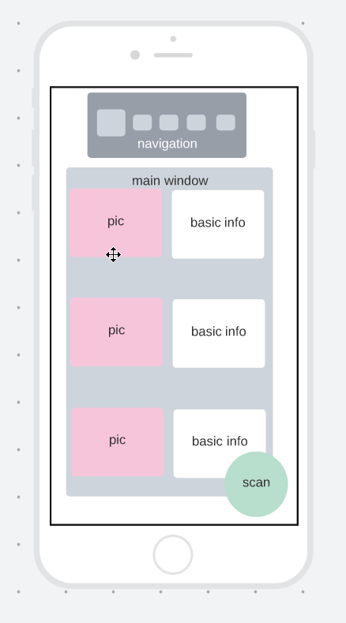

Home Screen

The home screen can be seen after the user swipes the splash screen to get into the app.

This screen is also accessible from the navigation window.

There are two areas that have navigational functions. Each utilizes the touch functionality of the mobile app.

The navigation window is in the same position on all the windows within the app except the splash screen and the scanner screen where the user scans the barcode of their chosen food.

Each box / button in the navigation window is an icon depicting where the user can navigate to.

The icon box is extra large if the user is on the screen related to that icon.

The scan button is a floating action button which is on every screen except the actual barcode scanner screen.

The scan button is always at the bottom right-hand corner of the screen.

The results from the barcode scan are first shown in the home screen with a picture and basic nutritional info.

If there have been no barcode scans completed before accessing this screen there will be a message in the window directing the user to use the barcode scanner to see the desired information.

Lower Cost Alternatives Screen

The lower cost alternatives screen is accessible from the splash screen.

This screen is also accessible from the navigation window.

The navigation window sits at the top of this screen as it does in the other areas where the navigation window is viewable.

The scan button is a floating action button which is on every screen except the actual barcode scanner screen.

The scan button is always at the bottom right-hand corner of the screen.

In the lower cost option window, the user can see the items they have previously scanned matched up with lower cost items of a similar type.

If there have been no barcode scans completed before accessing this screen there will be a message in the window directing the user to use the barcode scanner to see the desired information.

In retrospect I have been looking at how ‘name’ is bordered with a bolder color that stands out. In the app I would change this and make the lower cost name have the bolder border color as I would want people with lower incomes to feel encouraged and welcome to use the app. The boldness of the border may suggest psychologically that the bolded name is the better choice.

**Explain the rationale behind your design decisions.**

The rationale behind the splash screen is so that the user can have the option to start in their preferred location of the app. Users will have differing opinions on which part of the app is the most valuable to them and so should be given the option to start in their preferred screen.

The home screen is necessary as a place holder for the information that the barcode scanner.

There were two apps that I researched to help come up with my final decision on how this app should look and work. One part that really stood out to me was navigation. While the two apps are quite different from each other, both had certain starting points of which the user had no control. This affected me as I feel the user should feel in full control of an app they are using. It is also quite clear how the navigation works so the user does not have to use their own time working out how to navigate to different parts of the app as navigation is clearly visually displayed.

Something I agreed with while looking at other apps was the use of photos when an item is scanned. This lets a user know the results are for the exact item they had scanned.

**Discuss how your wireframe could be adapted to a digital watch**.

Moving the app to a watch would mean changing the amount of information given at one time. Assuming that the watch can be used to scan items, then the issue is how much to put on each face. Instead of a navigation window I believe each icon in the navigation window would be a single face. A user could swipe to get to different icons and then the user can touch the desired icon to access info. The information should be simplistic. Perhaps a green happy face, a yellow non plussed face or a red angry face to depict the healthiness of the food item. Then the user can swipe to see the nutritional info. One swipe for carbs, another for fat content, etc.

**Discuss how your wireframe could be adapted to a touch-based kiosk**.

A touch-based kiosk would go in the opposite direction to the watch face. Presumably the kiosk would be part of the grocery isle in a store. It is assumed that the screen would be at least as large as a laptop so a lot more information could be shown. The phone app version would work fine at the kiosk, but it would not be necessary to stay as minimalistic as a phone app requires.